King Edward VII’s Hospital

Staff Nurse
Job Description Person Specification

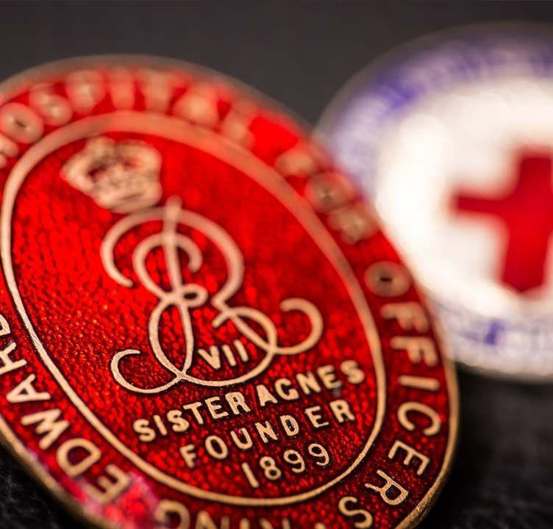

JOB DESCRIPTION
JOB TITLE: | Staff Nurse
RESPONSIBLE TO: | Ward Sister/ Charge Nurse
AREAS OF RESPONSIBILITY | Inpatient Wards,
Hours 37.5hrs p/w (Internal Rotation)
Days, Nights and Weekends

KEY WORKING RELATIONSHIPS: Patients, Visitors, Relatives, Clinical Nurse Specialists, Nursing and Allied Health Professionals, Consultants, Support Staff, Governance, Infection Control Team, Heads of Department, Heads of Service, Executive Directors.

JOB SUMMARY
An exciting opportunity is available for a Staff Nurse, to join our well-established Nursing Team at the prestigious King Edward VII Hospital, working with the vision of delivering excellence in care.
The hospital’s specialities include colorectal, urology, orthopaedics, men’s health and women’s health which is provided by a friendly, professional and supportive team who are focused on being a centre of excellence for a wide variety of surgical procedures and treatments. You will be part of a team that cares for a wide range of surgical patients. This is the ideal role for a nurse wishing to develop and extend both their clinical and leadership experience in surgical nursing. We offer a different approach to private healthcare and offer a variety of specialist treatments and complex procedures, which are simply not available from other providers.

Our Values are:
Professionalism – We encourage our teams to be the best they can
and meet the highest standards through:
- Acting with integrity
- Accountability
- Continued learning
Quality – We will provide excellence in everything we do through:
- Innovation
- Listening to and acting on feedback
- Measuring outcomes and informing actions
Respect – We will respect other people’s views to ensure an open inclusive
working environment through:
- Compassion
- Dignity
- Honesty
Safety – We are committed to providing a safe environment for our patients and

colleagues through:
- A learning culture
- Freedom to speak up
- Transparency
Teamwork – We work as a team so we achieve more together by being:
- Collaborative
- Fair
- Open

Key Duties and Responsibilities

- Carry out planned care for a group of patients without direct supervision
- Ensure the assessment, planning, implementation and evaluation of evidence based individualised patient care
- Assist and advise staff, both registered and unregistered in the delivery of patient care
- Maintain accurate clinical observations of the patient and act accordingly
- Have responsibility for the correct administration and custody of medicines according to Hospital policy
- Monitor patients progress, work towards safe and timely discharge plans and ensure barriers or delays to discharge are identified and acted on appropriately
- Act as the patients advocate.
- Communicate effectively at all times and maintain a harmonious working environment
- Develop new skills and knowledge pertaining to the speciality as advised by the senior sister or charge nurse
- Take responsibility for self-development through the appraisal system and work towards completing agreed personal development plan
- To undertake responsibility for tasks delegated

Professional

To keep up to date with current developments in nursing and ensure evidence based practice

To be aware and to endorse the Hospital’s Nursing Strategy within their role and the team.
- Ensure that nursing practices comply with Hospital policies and procedures
- Conduct oneself in accordance with the NMC Code of Conduct and Trust policies

Clinical
- Maintains accurate clinical observations of the patient using early warning indicator if indicated, document relevant clinical information in multidisciplinary notes and act accordingly.
- Undertake nursing procedures
- Monitor patients progress, work towards safe and timely discharge plans and ensure barriers or delays to discharge are identified and acted on appropriately
- Act as the patients advocate

Helps to manage concerns raised by patients, visitors and staff in a proactive, timely fashion and take remedial actions as necessary

To promote and maintain professional confidentiality at all times in accordance with

the Data protection Act 1998.

To liaise with Resident Medical Officers and Consultants to ensure that appropriate care is provided.

To work with the hotel services team to maintain the highest standards of cleanliness and patient environment.

To work with the Infection Control Team to prevent and control hospital acquired infection on the ward.

Education

Assist in the teaching and development of nursing assistants, students and junior staff, helping them to achieve their learning outcomes
- To keep up to date with current developments in nursing and ensure evidence based practice

Act as a role model and mentor to new starters, nursing assistants, pre-registration students and nurses undertaking supervised practice and return to nursing programmes

Undertake link nurse responsibilities when required and participate in appropriate training and cascade of information

Assist in the orientation of new staff and students

Measurements
- Patient reported outcome measures, patient satisfaction and experience
- Adherence to NICE Guidelines and Professional Standards

King Edward VII’s Hospital values our diverse workforce and is commitment to providing equal opportunities. We welcome everyone – all talents and backgrounds. Being a relatively small hospital in size enables all our staff to work as a tightly-knit team. If you can see yourself as part of this team, and we have a vacancy that suits your skills, we look forward to hearing from you.

Person Specification

Attribute | Criteria | Essential | Desirable | Assessment
Education, Qualifications and Training | Qualified RGN | ✓ |  | CV
 | Current NMC Registration. | ✓ |  | CV
 | Educated to Degree level in health-related subject or equivalent. |  | ✓
 | Evidence of stretching CPD |  | ✓ | CV
Knowledge and Experience | 1 year or more clinical experience in an acute healthcare environment.  Good verbal and written Communication Skills  Basic IT skills  Surgical Knowledge and Experience | ✓  ✓ | ✓  ✓ | CV & Interview  CV & Interview  CV & Interview  CV & Interview

Attribute | Criteria | Essential | Desirable | Assessment
Skills and Behaviours | Demonstrate your scope of practice underpins the six fundamental values of the 6 C’s (Care, Compassion, Competence, Communication, Courage and Commitment) and the care they deliver to the patient at the point of contact treats them with respect and dignity. | ✓ |  | CV & Interview
 | Demonstrate the KEVII Values  - Professional  - Quality  - Respect  - Safety  - Teamwork | ✓ |  | CV & Interview

