Christmas Card Purchase Form
10 Cards and Envelopes £5.00
The greetings inside these cards read:

‘With Best Wishes for Christmas and a Happy New Year’
‘Merry Christmas and a Happy New Year’
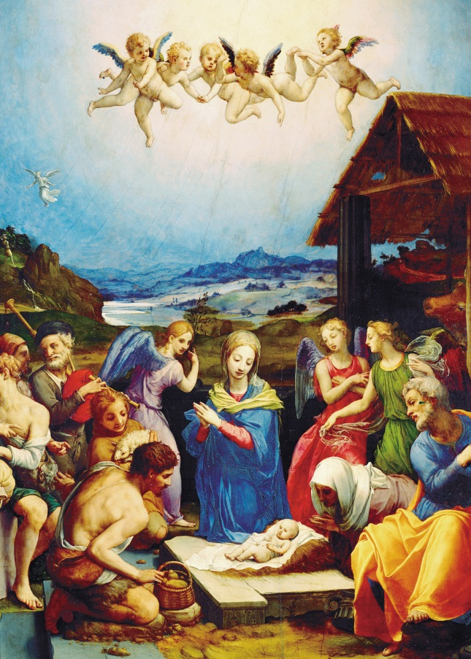
Bronzino, Adoration of the Shepherds Robin and Holly
Your Details

Name
Address
Telephone No.
Email address:

Card Title | Cost per pack | No. of packs | Total
Bronzino, Adoration of the Shepherds | £5.00
Robin and Holly | £5.00
 |  | Sub Total
 |  | Postage & Packing  (up to and including 4 packs) | £3.50
 |  | Total Payment

□ I enclose a cheque made payable to ‘King Edward VII’s Hospital’.
□ Please debit my: □ VISA □ MasterCard
Cardholder’s name ………………………………………………………………………………………..
Signature ………………………………………………………………………………………..
Card No. □□□□ □□□□ □□□□ □□□□
Start date □□/□□ Expiry date □□/□□ Security No. □□□

